**Practical 7:**

**Objective**: Solving Linear Algebraic Equations (LU Decomposition)

**Part A: LU Decomposition with Pivoting**

Just as for standard Gauss elimination, partial pivoting is necessary to obtain reliable solutions with LU decomposition. One way to do this involves using a permutation matrix. The approach consists of the following steps:

1. Elimination. The LU decomposition with pivoting of matrix [A] can be represented in matrix form as
$$[P][A]=[L][U]$$

2. Forward substitution. The matrices [L] and [P] are used to perform the elimination step with pivoting on {c} in order to generate the intermediate right-hand-side vector, {z}.
$$[L]\{z\}=[P]\{c\}$$

3. Back substitution. The final solution is generated in the same fashion as done previously for Gauss elimination.
$$\left[U\right]\left\{x\right\}=\{z\}$$

4. Compute the LU factorization and find the solution for the following system:

$$\left[\begin{matrix}0.0003 & 3.0000 \\ 1.0000 & 1.0000\end{matrix}\right]\left\{\begin{aligned}x_{1} \\ x_{2}\end{aligned}\right\}=\left\{\begin{aligned}2.0001 \\ 1.0000\end{aligned}\right\}$$

**octave:13>** A = [0.0003 3.0000; 1.0000 1.0000]

A =

3.0000e-04 3.0000e+00

1.0000e+00 1.0000e+00

**octave:14>** C = [2.0001; 1.0000]

C =

2.0001

1.0000

**octave:15>** [L U P] = lu(A)

L =

1.00000 0.00000

0.00030 1.00000

U =

1.00000 1.00000

0.00000 2.99970

P =

Permutation Matrix

0 1

1 0

**octave:16>** Z = L\P*C

Z =

1.0000

1.9998

**octave:17>** X = U\Z

X =

0.33333

0.66667

1. Given $A=\left(\begin{matrix}1 & 2 & 3 \\ 4 & 5 & 6 \\ 7 & 8 & 0\end{matrix}\right)$, use partial pivoting to find the LU decomposition $PA=LU$ where P is the associated permutation matrix.

**octave:18>** A = [1 2 3; 4 5 6; 7 8 0]

A =

1 2 3

4 5 6

7 8 0

**octave:2>** [L U P] = lu(A)

L =

1.00000 0.00000 0.00000

0.14286 1.00000 0.00000

0.57143 0.50000 1.00000

U =

7.00000 8.00000 0.00000

0.00000 0.85714 3.00000

0.00000 0.00000 4.50000

P =

Permutation Matrix

0 0 1

1 0 0

0 1 0

**Part B: MATLAB Matrix Manipulations**

The lu function expresses a matrix X as the product of two essentially triangular matrices, one of them a permutation of a lower triangular matrix and the other an upper triangular matrix. The factorization is often called the LU, or sometimes the LR, factorization. X can be rectangular.

$[L,U] = lu(X)$ returns an upper triangular matrix in U and a "psychologically lower triangular" matrix (i.e., a product of lower triangular and permutation matrices) in L, so that $X = L*U$.

$[L,U,P] = lu(X)$ returns an upper triangular matrix in U, a lower triangular matrix with a unit diagonal in L, and a permutation matrix in P, so that $L*U = P*X$ .

1. Create matrix $A=\left(\begin{matrix}1 & 2 & 3 \\ 4 & 5 & 6 \\ 7 & 8 & 0\end{matrix}\right)$.

**octave:3>** A = [1 2 3; 4 5 6; 7 8 0]

A =

1 2 3

4 5 6

7 8 0

1. Find upper triangular matrix, U

**octave:4>** [L1, U] = lu(A)

L1 =

0.14286 1.00000 0.00000

0.57143 0.50000 1.00000

1.00000 0.00000 0.00000

U =

7.00000 8.00000 0.00000

0.00000 0.85714 3.00000

0.00000 0.00000 4.50000

**octave:5>** [L2, U, P] = lu(A)

L2 =

1.00000 0.00000 0.00000

0.14286 1.00000 0.00000

0.57143 0.50000 1.00000

U =

7.00000 8.00000 0.00000

0.00000 0.85714 3.00000

0.00000 0.00000 4.50000

P =

Permutation Matrix

0 0 1

1 0 0

0 1 0

1. What is the lower triangular matrix

L2 =

1.00000 0.00000 0.00000

0.14286 1.00000 0.00000

0.57143 0.50000 1.00000

1. What is the relationship between L1 and L2?

P * L1 equals to L2

1. Verify that L2*U is a permuted version of A.

**octave:11>** L2*U - P*A

ans =

0 0 0

0 0 0

0 0 0

1. Compute $inv(U)*inv(L1)$, $inv(U)*inv(L2)$ and $inv(P)*inv(A)$.

**octave:12>** inv(U) * inv(L1)

ans =

-1.77778 0.88889 -0.11111

1.55556 -0.77778 0.22222

-0.11111 0.22222 -0.11111

**octave:13>** inv(U) * inv(L2)

ans =

-0.11111 -1.77778 0.88889

0.22222 1.55556 -0.77778

-0.11111 -0.11111 0.22222

**octave:14>** inv(P) * inv(A)

ans =

1.55556 -0.77778 0.22222

-0.11111 0.22222 -0.11111

-1.77778 0.88889 -0.11111

1. Find the determinant of A

**octave:15>** det(A)

ans = 27.000

1. Use MATLAB matrix manipulation to solve the following $\left[P\right]\left\{x\right\}=\left\{Q\right\}$ problem

$$\left(\begin{matrix}150 & -100 & 0 \\ -100 & 150 & -50 \\ 0 & -50 & 50\end{matrix}\right)\left\{\begin{matrix}x_{1} \\ x_{2} \\ x_{3}\end{matrix}\right\}=\left\{\begin{matrix}588.6 \\ 686.7 \\ 784.8\end{matrix}\right\}$$

**octave:16>** P = [150 -100 0; -100 150 -50; 0 -50 50]

P =

150 -100 0

-100 150 -50

0 -50 50

**octave:2>** Q = [588.6;686.7;784.8]

Q =

588.60

686.70

784.80

**octave:3>** [L, U] = lu(P)

L =

1.00000 0.00000 0.00000

-0.66667 1.00000 0.00000

0.00000 -0.60000 1.00000

U =

150.00000 -100.00000 0.00000

0.00000 83.33333 -50.00000

0.00000 0.00000 20.00000

**octave:4>** Z = L\Q

Z =

588.60

1079.10

1432.26

**octave:5>** X = U\Z

X =

41.202

55.917

71.613

1. Solve the following problem using LU Decomposition.

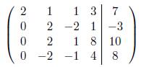

**octave:26>** A = [2 1 1 3; 0 2 -2 1; 0 2 1 8; 0 -2 -1 4]

A =

2 1 1 3

0 2 -2 1

0 2 1 8

0 -2 -1 4

**octave:27>** B = [7;-3;10;8]

B =

7

-3

10

8

**octave:28>** [L,U,P] = lu(A)

L =

1 0 0 0

0 1 0 0

0 1 1 0

0 -1 -1 1

U =

2 1 1 3

0 2 -2 1

0 0 3 7

0 0 0 12

P =

Permutation Matrix

1 0 0 0

0 1 0 0

0 0 1 0

0 0 0 1

**octave:29>** Z = L\B

Z =

7

-3

13

18

**octave:30>** X = U\Z

X =

1.541666666666667

-1.416666666666667

0.833333333333333

1.500000000000000

**Part C: Programming Practice (without pivoting)**

1. Write a program to find LU Decomposition for a given 2x2 matrix.

**Example:**

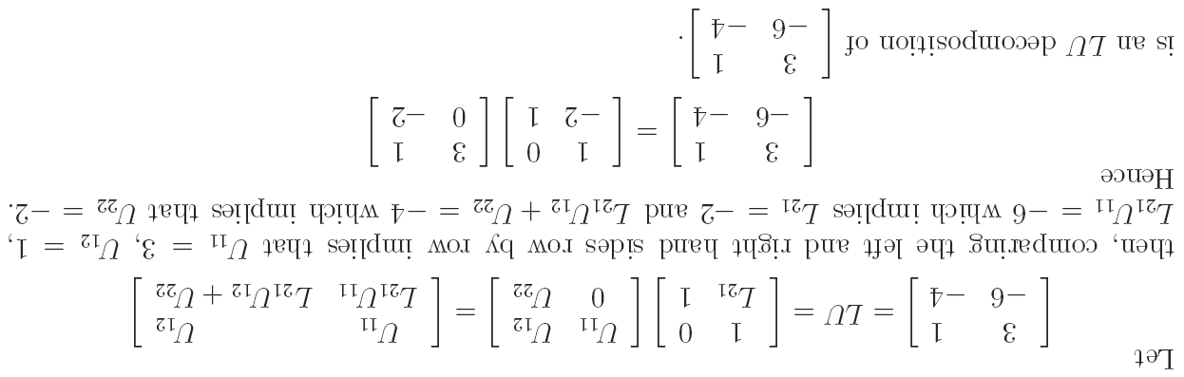

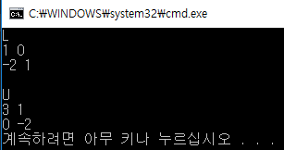

1. Write a program to find LU Decomposition for a given 3x3 matrix. Verify the correctness of your program by using results from Problem B (Question 8 ).

